**EXPERIMENT-1**

**Design a circuit to blink a LED**

**CIRCUIT:-**

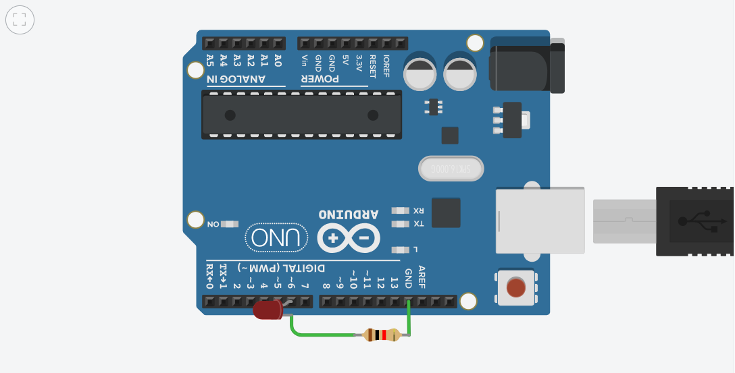

**Concept**:-

An arduino is on board microcontroller. And it can be programmed via the language processing to turn a LED on for a certain period of time and turn it off in a loop. To control the amount of time the LED will be on and the amount of time it will be off can easily be decided by a predefined function i.e. delay (), this function take time as The argument(in millisecond).

**The LED**:-

LED stands for “Light Emitting Diode”.

An LED is a small light that emits visible light when an electric current passes through it. The light is not particularly bright, but in most LEDs it is monochromatic, occurring at a single wavelength. It is consists of two elements: 1. P-type Semiconductors 2. N-type Semiconductors the positive side of LED is called “Anode” and the negative side of the LED is called “Cathode.” The flow of current is from anode to cathode but current cannot flow from cathode to anode that means it only allows forward current to flow through the circuit and block the backward current.

**Connection of Arduino UNO circuit board:-**

In Arduino we have 14 input output digital pins numbered from 0 to 13 and on digital side we have one “gnd” pin also. We can use any digital input output pin for input and output. In our experiment we use digital pin 13 through which we connect positive terminal of LED and the negative terminal of LED is connected to the ground pin named as “gnd” on Arduino board. Arduino is programmed to give output from digital pin 13 and “gnd” provide return path way for current.

|  |
| --- |
|  |
|  |
|  |
|  |
|  |
|  |
|  |

**Apparatus:-**

Arduino board, LED, Resistance of 220ohm and Jumper Wires.

**Problems and Troubleshooting:-**

|  |  |  |  |  |  |
| --- | --- | --- | --- | --- | --- |
| * LED is not turning on:-Check for the polarity and make sure its P end is connected to the cathode and N end is connected to the anode. * Arduino Board is not working:-Make sure that the pins are not shorted. Connect USB type A to B properly and re-upload the sketch. * Right code must be used.   **Learning and Observations:** -  In this experiment we learnt about:   1. We learnt about the LED. 2. Basic coding used in Arduino UNO. 3. Interfacing an LED with Arduino UNO board.   **Observations:-**   1. If we change the delay to any other value, the blinking of LED is also change according to the value of delay. For example we change the value of delay 1000ms to 2000ms, the blinking of LED become slower. 2. When delay becomes 50ms, then we cannot notice the blinking of LED. It looks like it is continuously glowing.   **Learning Outcomes:-**   1. Learned to use the following arduino Methods/functions:- 2. digitalWrite() 3. pinMode() 4. delay() 5. Structure of the Arduino sketch. 6. Learned to connect the components in a logical way with respect to the written code.  |  | | --- | |  | |  |  | |  |  | |
|  |

**Precaution:-**

1. Don't plug in an LED without a current limiting resistor.
2. Don't supply more than 9V unless proper knowledge.
3. Check all the connections.